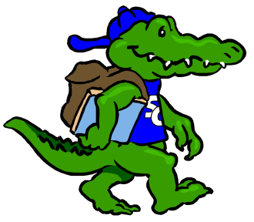
Sycamore Creek Elementary
Staff Profile
Name: Gloria Dragonette |  | Grade: 3
Favorite Color? | blue
Favorite Flower? | Any flowering plant!
Favorite Food? | pizza
Favorite Fruit? | cherries
Favorite Drink? | Diet Cherry Coke
Favorite Dessert? | Oreos
Do you like Candy? (What kind?) | Yes! Twizzlers Cherry Pull ‘n Peel
Favorite Restaurant? | Maggiano’s
Favorite Store? | Target
If you could receive a gift card, what store would you like? | Movie Theaters: Regal/Carmike/Stone’s, Kohl’s, Target, Barnes and Noble
Hobbies? | Walking, hiking, biking, Zumba, movies, reading
Things you like? | I love history, especially American History/historical fiction books
Any dislikes? | Cut flowers

Items Needed for Our Classroom
Child-sized scissors
White paper towels
Thin regular markers
Thin dry-erase markers
Mailing labels

